
Get Creative on the Telephonic Youth Project

Are you aged 14-19? Do you want to develop your creative skills, with the option of completing a Discover to Bronze Arts Award?
Are you interested in thinking about big questions about young people’s phone use today and in a pre-digital era, in the 1980s and 1990s?
If yes, then the Telephonic Youth Project is for you. You will work with a professional artist to create your own art and put together a free public exhibition of your artwork at the John Hansard Gallery with professional curators.
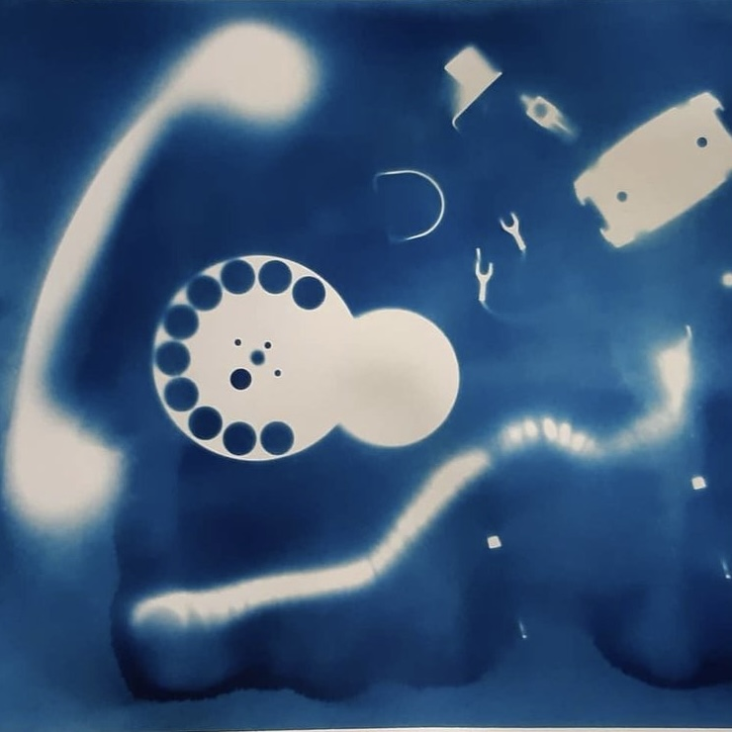
Sessions are taking place from November 2021 to March 2022. These will be held on Wednesday evenings, from 5.30pm to 7.30pm at the Gallery.

To sign up, please call 023 8059 3251 or email kat@jhg.art

Telephonic Youth is on Twitter and Instagram, and you can visit their website: https://telephonicyouth.co.uk
Photo: J Walters

The workshops are part of a research project happening at the University of Southampton, Ethics Research Governance Online number: 56966. The research is sponsored by the Arts and Humanities Research Council, part of UK Research and Innovation.


FAQs Telephonic Youth Project Art Workshops

What is the Telephonic Youth Project about?
These art workshops are taking place as part of a research project, led by Dr Eve Colpus at the University of Southampton in collaboration with John Hansard Gallery and BT Heritage & Archives, looking at the heritage of young people’s phone cultures. The research project’s website is https://telephonicyouth.co.uk/.
Follow the project on Twitter @TelephonicYouth and on Instagram @telephonicyouth

Where are the workshops being held?
The workshops are held at John Hansard Gallery, 142 – 144 Above Bar Street, Southampton, SO14 7DU.

What are the dates and times of the workshops?
The workshops are on Wednesday evenings from 5.30pm-7.30pm at the Gallery on the following dates:
10 November
24 November
8 December
26 January
2 February
16 February
2 March
16 March
23 March

The young people’s artwork will be on show in a free community exhibition at the John Hansard Gallery in April and May 2022.

Who runs the sessions?
A professional artist and teacher, Russell Squires, is running the sessions. There will always be a Gallery Assistant at each session aswell.

What languages are the workshops in?
The workshops are in English.

How old will other people be in the group?
This workshop series is for 14-19 year olds.

I / the young person in my care would like to come to the workshops, but I /they haven’t done art classes before. Is this a problem?
No, you don’t need to have done any art classes before to be able to come to the workshops. Every young person in the group will be supported by the artist and Gallery Assistant to do the activities.

Will I / the young person in my care need to bring any materials?
No, everything will be provided at the Gallery.

Does taking part lead to any qualifications?
Taking part in these workshops can go towards the young person completing their Arts Award. The Gallery team will provide information about this opportunity and will support any young person who wishes to do their Arts Award.

Will there be consent forms to sign to join?
The workshops are part of a research project, run by Dr Eve Colpus at the University of Southampton. We will give you a booklet to read which explains what will happen in the art workshops. If you would like this booklet in audio version, please email kat@jhg.art or call 023 8059 3251

There will be a consent form to sign to take part in the workshops. If the young person you are responsible for is under 18, we will ask them and you to sign the consent form to confirm that you are both happy for them to take part in the workshops. We can provide help if you need assistance filling in the form.

Will I / the young person in my care need to bring food and drink?
There will be a break during each of the workshops when the group will be given pizza if they want it. Please bring your own drink / drink container.

Can the young person bring a friend who is not completing the workshops?
No, unfortunately, we are only able to run the workshops for the young people who have signed up.

Parents/guardians – can we drop off the young person in our care at the workshops?
You can drop off / pick up at the Gallery. Nearby pay and display car parks are within walking distance at Grosvenor Square Car Park, Bedford Place, Civic Centre Forecourt and West Quay Car Park. All car parks have accessible spaces for Blue Badge holders. There are a number of bus stops within close walking distance to the Gallery aswell.

What is happening at John Hansard Gallery around Covid-19?
The safety of our staff and visitors is very important to us. We are continuing with our safety measures to make your visit as enjoyable and safe as possible.
If you feel ill or have been asked to self-isolate, please don’t come to the building.
Our staff will continue to wear face coverings and visitors are strongly encouraged to do the same.
We will continue to provide hand-sanitising stations and visitors will be encouraged to regularly wash their hands.
You are encouraged to maintain social distancing from anyone not in your group during your visit.
We will ask you to follow our one-way route around the building. Our lifts will continue to be reserved for users with accessibility issues.

If you have any questions, please email kat@jhg.art or call 023 8059 3251. You can also ask for information at the front desk of John Hansard Gallery; the Gallery is open 11am-5pm Tuesday to Saturday.

